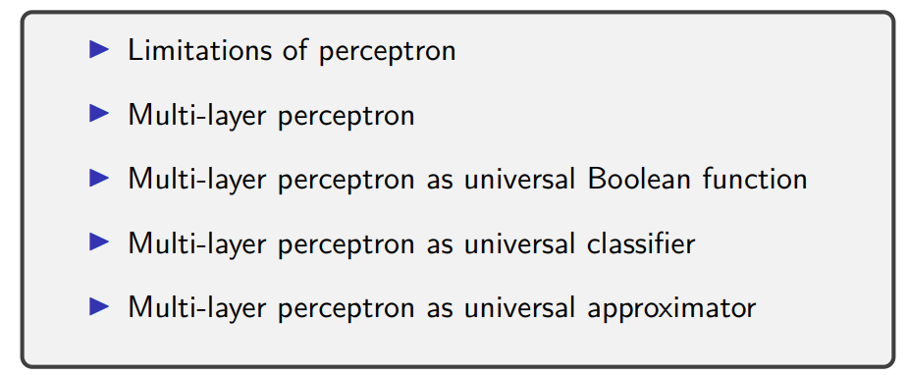

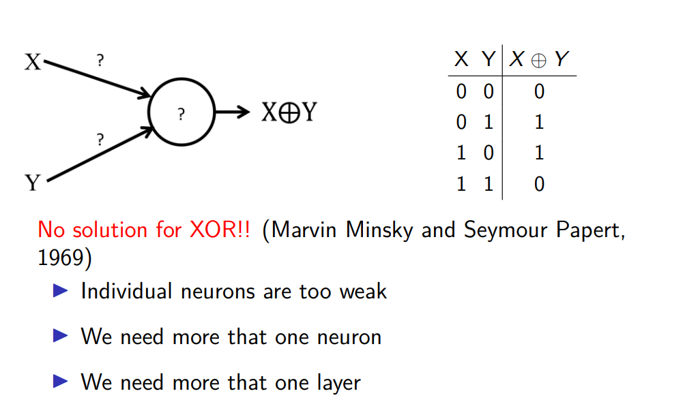

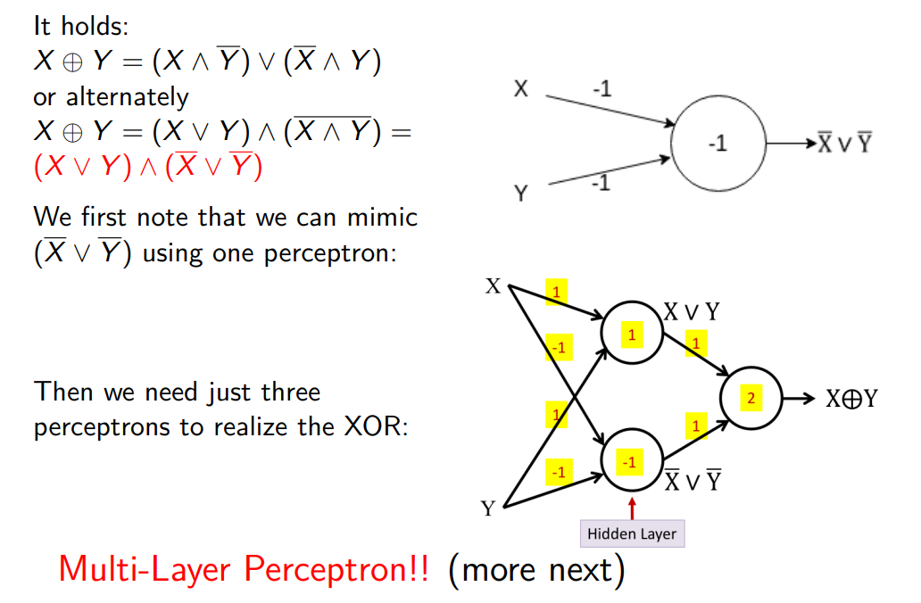
we can represent different functions with the same truth table.

we need to have true X or Y but not X and Y at the same time (we must negate the and).

¬X v ¬Y ⟹ perceptron with both X and Y weights equal to -1 and threshold set to -1
X = 1 and Y = 0 ⟹ we got -1 and since the threshold is -1 the neuron fire fires
same for
X = 0 and Y = 0.
The neuron does not fire only when X and Y are both equal to 1.

X v Y done before (done with both weights equal to 1 and threshold set to 1)

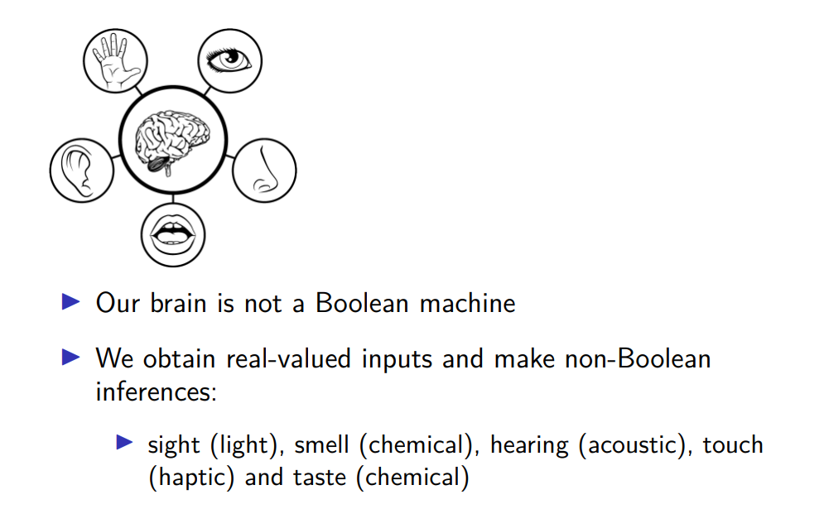

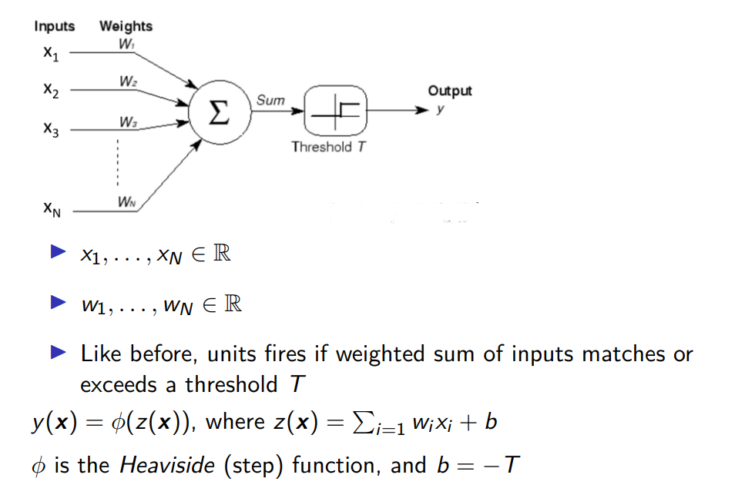
consider perceptorn with real inputs
we say the individual inpots belongs to IR
and the weights also belongs to IR

the weighted sum of the input undergoes the threshold
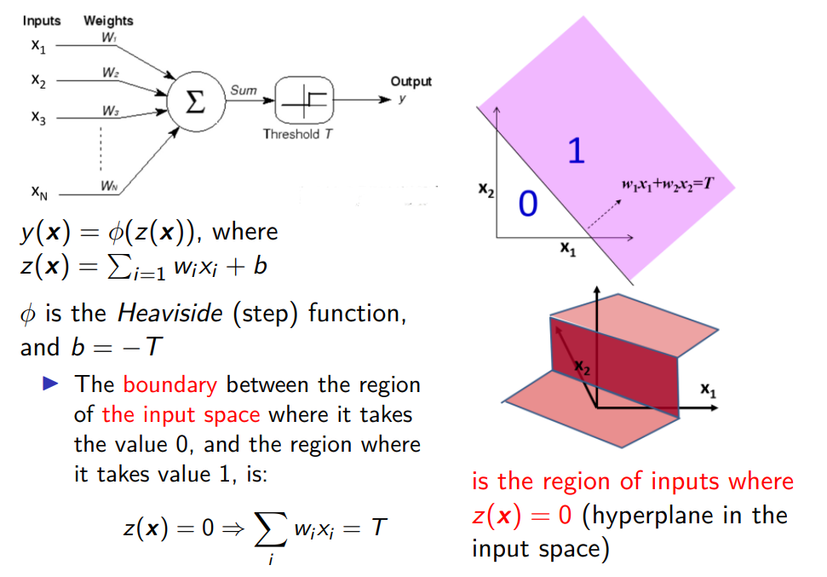

the percetron divide the space in two regions, 0 and 1

0 region where for any couple of inputs in this area it remans unfire
1 region where any points in violet region are those caples in which our neuron fire

the lines is z(x) = 0 (exaclty the threshold)

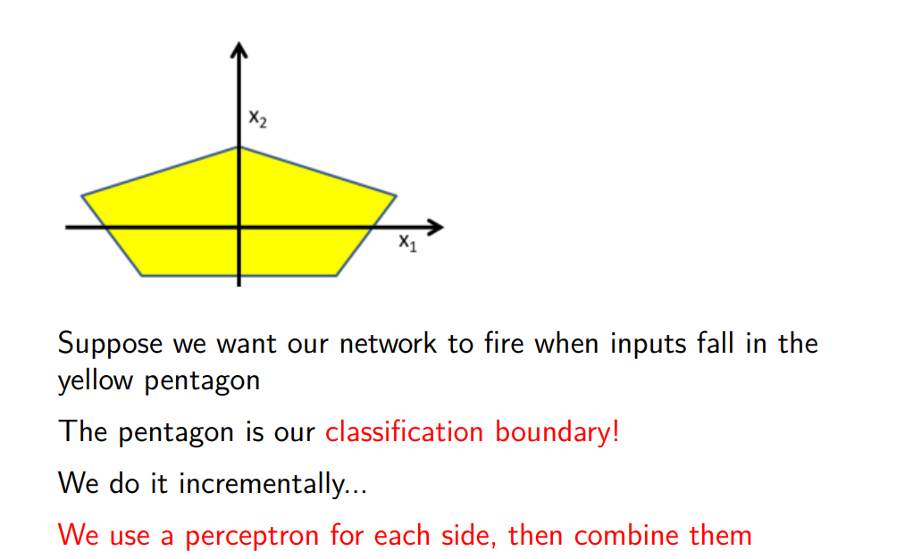
more complex region. Is it possible to still use the perceptron?

yes. We can do incrementally
effeclty each side is linear, potentially is a linear boundary.
the idea is to take individual perceptron recognising each of these boundary and then combine them

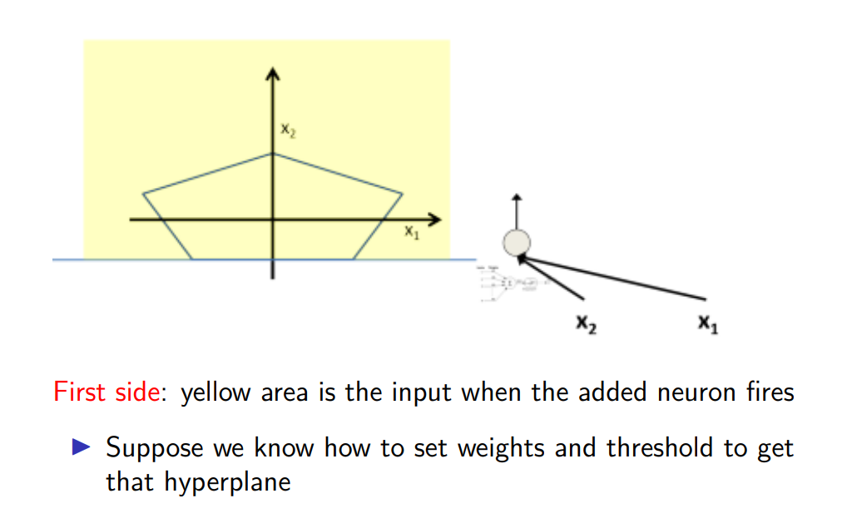

set the threshold, we can make 1 in the above region, 0 below

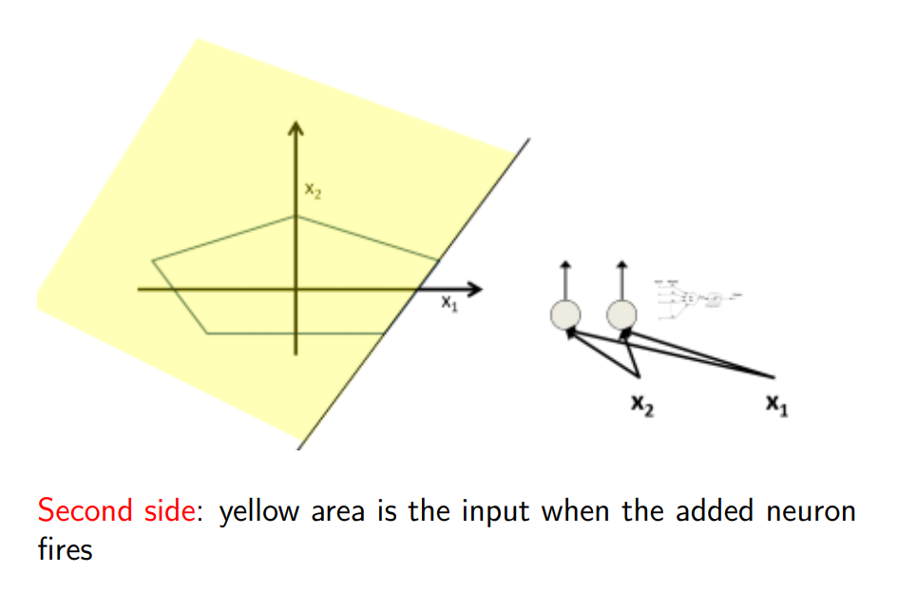

second perceptron, everything in yellow part activiates further

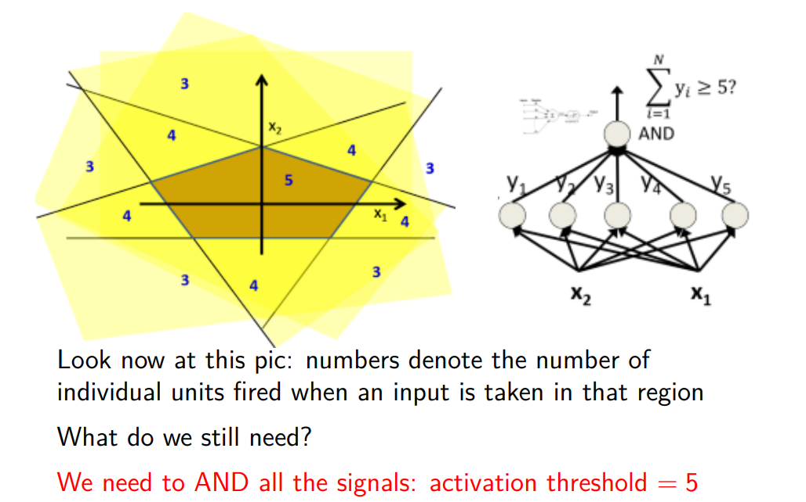

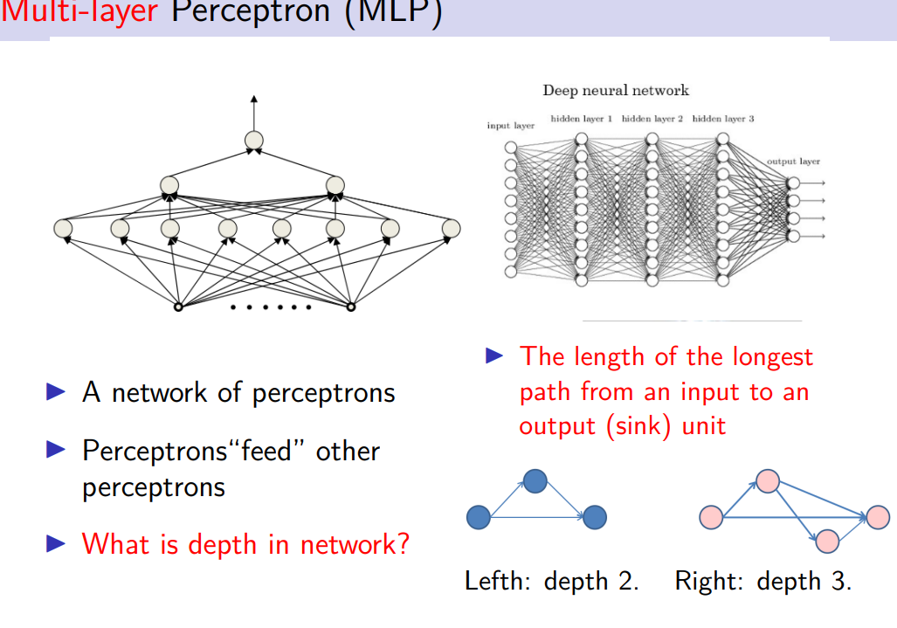

depth: number of edges define in the longest path connecting an input to an output neuron

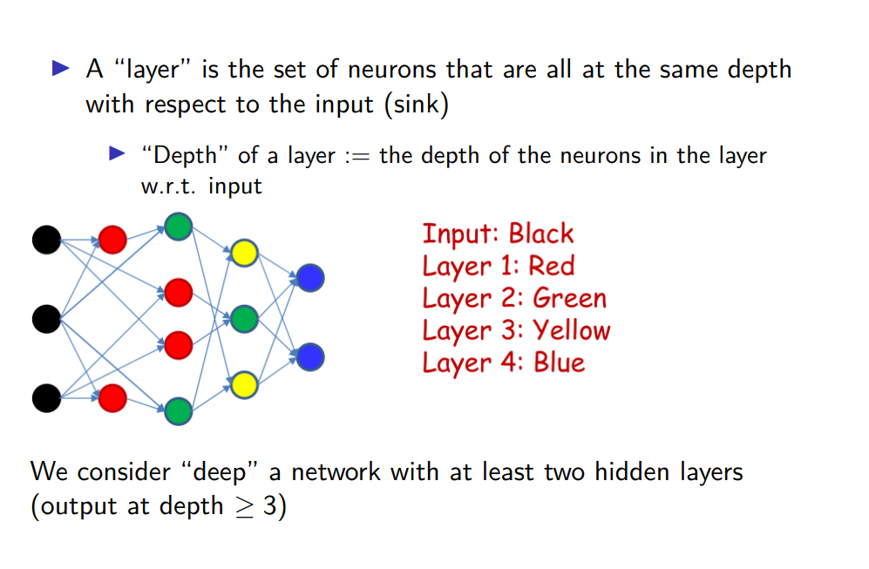
layer: set of neorun in the same depth

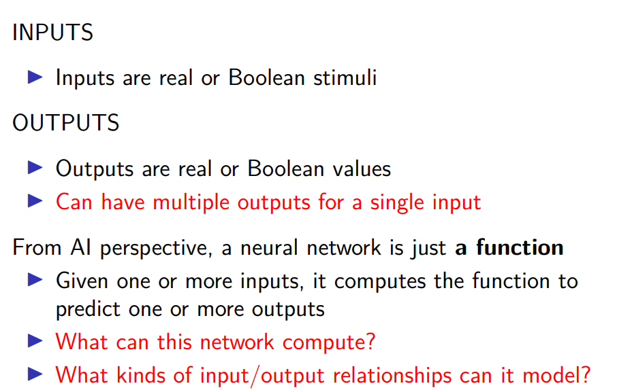

4 possible classes

2 output neuron (boolean) which output 0 0 for 1first class 01 for second class 10 third class and 11 for 4class

